COAST TO COAST – NWK Group of the Ramblers
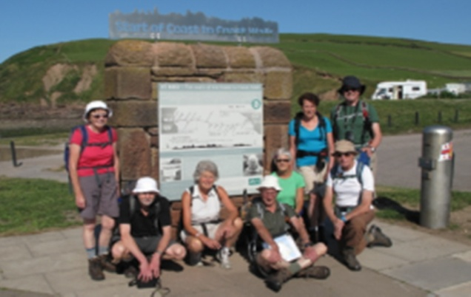
Nine members of the group left London on Monday 30 June to start Wainwright’s Coast to Coast walk, full of excitement and some trepidation! We knew it was going to be an interesting holiday following various events which occurred to some of us on the way to Euston station and the chaos regarding seating on the train! Fortunately, we arrived at St Bees without any further mishaps, checked into the B&B and went for a relaxing drink before dinner.

On Tuesday we started by walking to the beach, taking photos at ‘Mile Zero’ and then going through the traditional ritual of putting our boots in the Irish Sea and picking up a stone to carry across the country to Robin Hood’s Bay. When walking to the sea we met a couple from Manchester who were getting married en route – saying their vows at the top of a mountain, conducting the official bit in a town, before celebrating with 80 family and friends with a fish and chip supper at Robin Hood’s Bay!! Hope it all went to plan for them.

The route took us round the coast and then inland across fields with views out to sea. We encountered our first climb up Dent and rewarded with sightings of the Isle of Man, the Lakeland fells and Sellafield! We were now well on our way and looking forward to the next two weeks!

Every day had its own challenges – the second day we took the high option which included Red Pike, High Stile, High Crag and Haystacks, climbing a total of 6,200 ft (we also had to come down…) and this wasn’t helped by a drop in temperature with high winds, sometimes gusting. Carole was blown over and rolled a couple of times, but her good deed for the day was breaking Christine’s fall when she fell!! Again, the views from the top were amazing, especially when we looked back to see where we had walked!

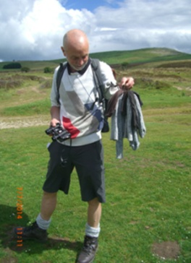
The next few days in the Lakes were magnificent although we did have heavy rain when leaving Grasmere which filled the gills and turned them into rivers. Crossing some of them was tricky resulting in a few wet socks and boots… Sadly, at this point Jack sustained an injury to his knee and was unable to continue from Patterdale.

We were then in limestone country with rolling hills and more great views and a good opportunity for Ron to dry his socks].

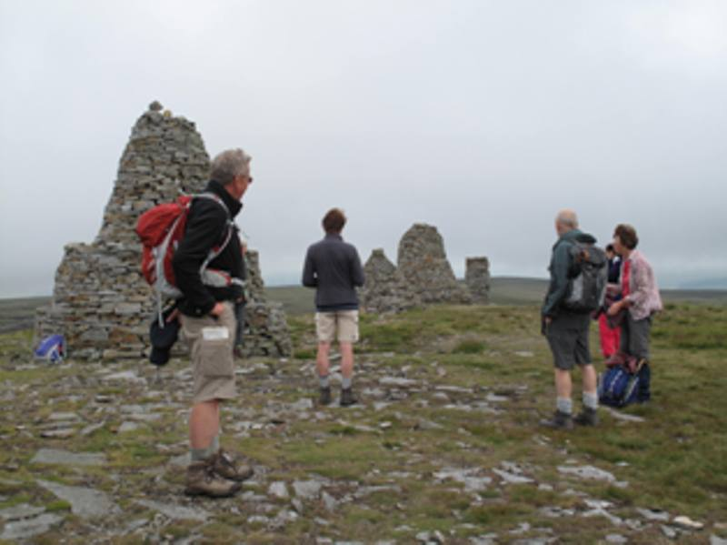
On day nine we left Kirby Stephen to walk to Keld passing Nine Standards. When we first glimpsed the Standards they were in mist and they gradually cleared as we approached only to be shrouded in the mist again – very atmospheric.

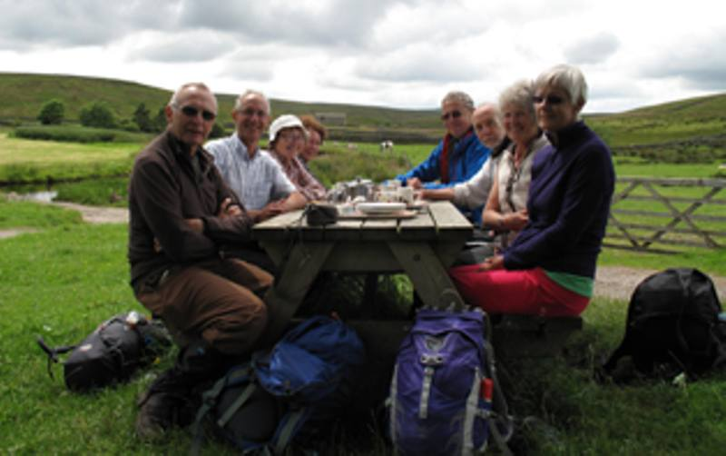
About three miles before Keld we stopped for tea and scones at Ravenseat Farm, the home of Amanda Owen who wrote “The Yorkshire Shepherdess”, based on her life as a farmer in the Dales.

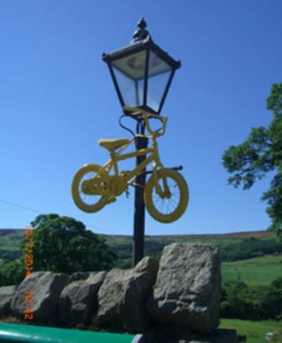

Walking in Yorkshire we saw many yellow bicycles, some hanging from trees and lamp posts, to celebrate the Tour de France starting in Leeds and going through the villages.

Day 12 was our rest day in Richmond – very welcome after 10 days of walking - and prepared us for the 26 mile marathon to Osmotherly! As expected, this was a tough day and the lunch stop at Danby Wiske was very welcome after 14 miles as was the Bluebell Inn at Ingleby Cross for a quick drink before tackling the three mile uphill climb to Osmotherly. We were then on the North York Moors.

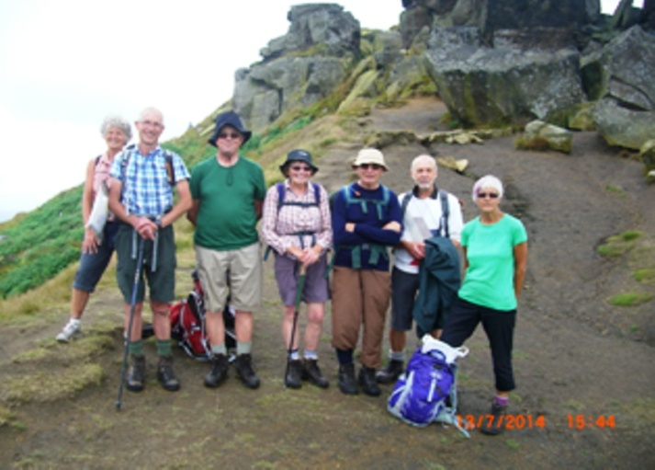
The next two days went well with great views all round. And then it was the last day with Robin Hood’s Bay beckoning! After leaving Glaisdale the walk was varied going through woods, over moors and bog and then out to the coast. We walked through Grosmont station, passed the Hermitage and Falling Foss waterfall and had our first view of Whitby Abbey and the North Sea. Looking back along the coastal path we could see where sections had fallen away during the winter.

What kept us going on the last stretch was the thought of a tea stop at one of the two caravan sites on the top of the cliffs. We passed the first site and were eagerly looking forward to the next one. On arriving at the café, it was definitely closed!!! The two Carol(e)’s were not happy which was aggravated by Mike tucking into the cake he had bought at our lunch stop!
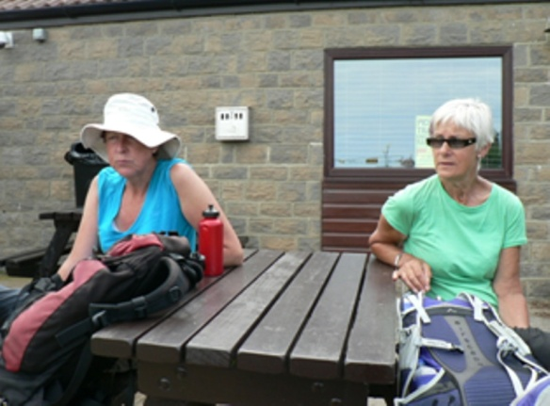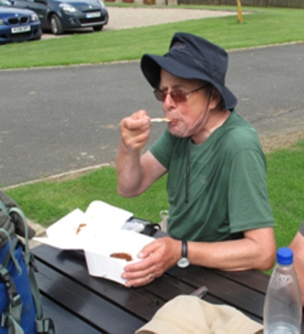

We then had our first glimpse of Robin Hood’s Bay – the climax of our two week trek. After checking into our B&B’s and leaving our rucksacks, we walked down to the slipway to carry out the traditional ceremony of putting our feet in the North Sea and throwing the stone we had picked up on the beach at St Bees into the sea at Robin Hood’s Bay. After a few photos, it was in the pub for a celebratory (and very welcome!) drink.

Along the route we met people from many parts of the world – Americans, Belgians and quite a few Australians. There were two Australian men we met on many occasions – usually in or near tea shops who became experts on scones en route! Another interesting group were eight Australian ladies who decided to do the walk to celebrate their 60th birthdays – the celebrations never stopped and they were a lot of fun.

We knew the walk would be challenging and it didn’t disappoint. We completed the 206 miles with great views, lots of laughs and good company. We had an interesting selection of B&B’s, especially the one with a hot tub!! and when staying at Old Water View in Patterdale, Bob and Christine were in the room Alfred Wainwright stayed in when he did the C2C. One experience not to be repeated would be to have a glass of wine at the Swan Hotel in Grasmere – we thought £9.50 a bit expensive!
And last of all, a BIG thank you to Jack for organising the holiday, which started as a casual suggestion on a walk in early 2013 …

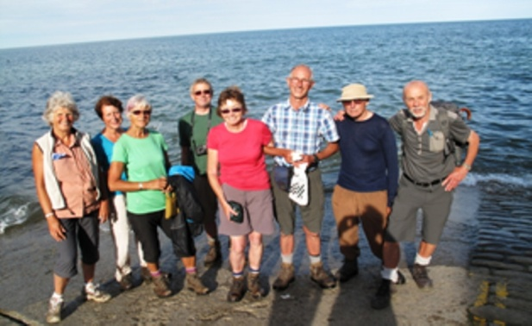
Carole Flowerday
July 2014

