Solihull & Shirley Performance Centre
Thank you for being a part of Solihull & Shirley! You may be unaware of many of our activities and I hope that this will address that.
ADULT GROUPS
Monday 8pm-10pm at Tudor Grange School – coach Andrew Kitching
Often referred to as the “Saints”, this group is aimed at adults of all standards with coaching provided. The “Saints” has a team in the Solihull League. At the moment, there are limited places available.
Wednesday 8pm-10pm at Langley – MAIN CLUB
Standard requirement of league level standard. The club are currently looking for new members and enter teams into the following leagues.
Coventry – 1 Mixed (Premier Div), 1 Men’s (New) and 1 Mixed team (New)
Solihull – 1 Ladies (1st Div), 2 Combined (1st & 2nd Div) , 2 Mens (1st & 2nd Div) & 1 Singles team (1st Div)
Birmingham – 2 Mens (1st & 2nd Div) , 1 Ladies (1st Div) & 2 Mixed (1st & 2nd Div)
JUNIOR GROUPS
Saturday 12:30pm-2:15pm at Langley – coach Paul Harris
A pay & play session aimed at Secondary school players of all standards. Also additional practice session for other junior group players. SPACES AVAILABLE
- Saturday 2:15pm-3:45pm at Langley – coaches Paul Harris, Steve Wainwright & Andrew Kitching supported by Tessa Franks, Harrison Franks & Alice Bray
Aimed at Primary School & Year 7 players. WE need new members – please advertise.
- Monday 6pm-7:30pm at Langley – coaches Paul Harris & Steve Wainwright
- Wednesday 6:15pm-8pm at Langley – coaches Rob Spink, Alison Franks, Ray Hilton & Chris Greenhill
Players normally move from groups from 1) to 2) and 2) to 3) based on age & standard.
Additional teams in Solihull League supported by junior groups – 2 Mens, 1 Ladies & 2 Junior
Warwickshire Senior Restricted Tournament – Sat 28th & Sun 29th Sept at Warwick Uni
The Warwickshire restricted is open to all players! Some great badminton to be seen. You are welcome to come along to watch!

Shirts
Shirts are available to all players at £15.
Sprudel Cup 3rd & 4th August in Bad Soden-Salmuenster, Germany
Our 12th year in the Sprudel Cup! A team tournament with points accumulated based on results in disciplines divided into 2 standards. Solihull & Shirley has won the trophy on 5 occasions.
This year’s team are already in training!

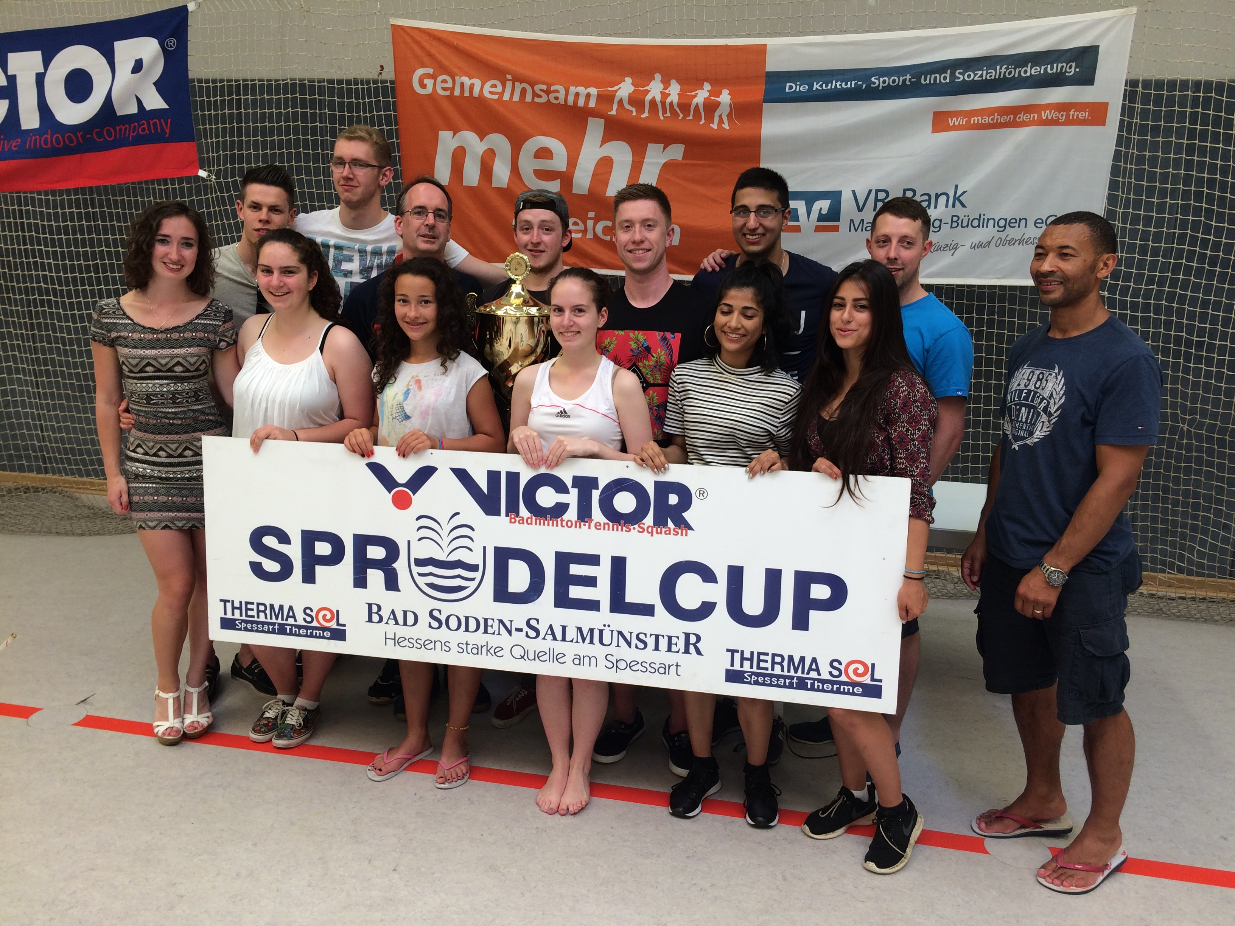

Please contact Paul on paharris20@hotmail.com or 07969 115630 if you have any questions.

